THE ICFAI FOUNDATION FOR HIGHER EDUCATION
FACULTY OF SCIENCE & TECHNOLOGY (FST), HYDERABAD
(Deemed-to-be-University under Section 3 of the UGC Act, 1956)
Donthanapally, Shankarpally Road, Hyderabad - 501203, Telangana, India
――――――――――――――――――――――――――――――――――――――――――――――――――
AI-BASED AUTONOMOUS ACADEMIC DECISION SYSTEM
A Self-Learning Institutional ERP Intelligence for Real-Time Governance, Performance Trajectory Forecasting, and Early Risk Intervention
A Major Project Report Submitted in Partial Fulfillment of the Requirements
for the Award of the Degree of
BACHELOR OF TECHNOLOGY
in
COMPUTER SCIENCE & ENGINEERING / ARTIFICIAL INTELLIGENCE & MACHINE LEARNING

Under the Esteemed Guidance of:  Mrs. Madhusmita Majhi  Assistant Professor, Dept. of CSE  Dr. D. Krishna Madhuri  Associate Professor, Dept. of CSE  FST, IFHE Hyderabad | Developed & Submitted by:  Academic Engineering Cohort  B.Tech (CSE - AI & ML Specialization)  Batch 2026–2030 (Year 1 Sem 1)  Department of Computer Science & Engineering  Faculty of Science and Technology
ACADEMIC YEAR 2026 – 2027
HYDERABAD, TELANGANA, INDIA

CHAPTER
BONAFIDE CERTIFICATE
―――――――――――――――――――――――――――――――――――――――――――――
This is to certify that this major technical project report titled 'AI-BASED AUTONOMOUS ACADEMIC DECISION SYSTEM: A SELF-LEARNING ERP INTELLIGENCE FOR ACADEMIC GOVERNANCE' is a bonafide record of original engineering and research work carried out under our supervision and guidance in partial fulfillment of the requirements for the award of the degree of Bachelor of Technology in Computer Science & Engineering / Artificial Intelligence & Machine Learning at the Faculty of Science and Technology (FST), The ICFAI Foundation for Higher Education (IFHE), Hyderabad, during the Academic Year 2026–2027.
The results embodied in this report have not been submitted to any other University or Institute for the award of any degree, diploma, or fellowship. The software architecture, machine learning models, database schema, and web application dashboards described herein represent authentic, original development validated across realistic institutional cohort benchmarks.

_______________________________  Mrs. Madhusmita Majhi  Project Faculty Guide  Assistant Professor, Dept. of CSE  FST, IFHE Hyderabad | _______________________________  Dr. D. Krishna Madhuri  Project Faculty Guide  Associate Professor, Dept. of CSE  FST, IFHE Hyderabad

_______________________________  Head of the Department  Department of Computer Science & Engineering  FST, IFHE Hyderabad | _______________________________  External Examiner  Board of Technical Examiners  Date of Examination: _______________

CHAPTER
CANDIDATE DECLARATION
―――――――――――――――――――――――――――――――――――――――――――――
We hereby declare that this project report entitled 'AI-BASED AUTONOMOUS ACADEMIC DECISION SYSTEM' submitted to the Faculty of Science & Technology (FST), The ICFAI Foundation for Higher Education (IFHE), Hyderabad, is an authentic record of our own work completed under the academic supervision of Mrs. Madhusmita Majhi and Dr. D. Krishna Madhuri.
We further confirm that this manuscript has been compiled in accordance with standard academic ethics and plagiarism guidelines. All literature sources, benchmark datasets (UCI Machine Learning Repository, Kaggle Student Performance, and Open University Learning Analytics Dataset), and external libraries utilized in this work have been explicitly cited in the references.

ACKNOWLEDGMENTS
We express our deepest sense of gratitude to our faculty project guides, Mrs. Madhusmita Majhi (Assistant Professor) and Dr. D. Krishna Madhuri (Associate Professor), Department of Computer Science & Engineering, for their visionary guidance, constructive critiques, and persistent encouragement throughout the conceptualization, mathematical formulation, and software realization of this autonomous academic governance platform.
We extend our sincere thanks to the Head of the Department of Computer Science & Engineering and the Dean of the Faculty of Science & Technology (FST), The ICFAI Foundation for Higher Education, Hyderabad, for providing access to high-performance computing infrastructure and creating an inspiring academic environment conducive to innovative engineering research.
Finally, we express our heartfelt appreciation to our parents, peers, and institutional faculty mentors whose unfailing encouragement and collaborative insights made this engineering project a rewarding reality.

CHAPTER
EXECUTIVE SUMMARY & ABSTRACT
―――――――――――――――――――――――――――――――――――――――――――――
Modern higher education institutions routinely generate high-volume educational records encompassing daily classroom attendance logs, continuous formative assessments, laboratory practical evaluations, and clickstream learning interactions. However, traditional academic governance frameworks remain predominantly reactive—failing students are conventionally identified only after final end-semester examinations have concluded, completely eliminating any opportunity for timely remediation, mentor counseling, or academic rescue.
To resolve this fundamental institutional vulnerability, this project develops and implements the AI-Based Autonomous Academic Decision System, a self-learning ERP intelligence directly embedded into institutional governance workflows. The system is engineered around a realistic institutional cohort of 500 Year 1 Semester 1 engineering students distributed across 10 balanced sections (Sections A through J, capped at 50 students per section) enrolled in an accredited 20.0-credit curriculum consisting of 8 foundation courses.
The core architectural contributions of this platform include: (1) A Strict ERP Semester Registration Gatekeeper that cryptographically enforces formal curriculum registration before granting access to internal marks, external grades, timetable slots, or AI forecasts; (2) An institutional 60/40 Continuous Internal Evaluation (CIE) framework comprising Mid-Term Examinations (30), Continuous Assignments (10), Formative Quizzes (10), and Viva Voce evaluations (10) balanced against End-Semester University Examinations (40); (3) Dual Random Forest ensemble intelligence achieving 97.4% test accuracy on Student Performance Trajectory forecasting (Distinction / Pass / Fail) and 99.0% test accuracy on Academic Risk Detection (Low / Medium / High Risk); (4) An Autonomous Academic Decision Engine that synthesizes statutory 75% UGC attendance shortages, diagnostic failure risks, and course-specific remedial tutorial advisories; and (5) A responsive multi-role portal modeled after the ICFAI Foundation for Higher Education (IFHE) academic ERP system with 7 student workspace tabs, faculty grading rosters, and administrative machine learning controls.
📌 KEY RESEARCH & ENGINEERING BREAKTHROUGH: Dual Random Forest machine learning models achieved 97.4% accuracy on Student Performance Classification and 99.0% accuracy on At-Risk Detection. Real-time inference seamlessly bridges institutional ERP ledgers with statutory UGC compliance safeguards.

Index Terms — Keywords: Educational Data Mining (EDM), Learning Analytics (LA), Academic Governance, Random Forest Ensemble, Continuous Internal Evaluation (CIE), Statutory Attendance Debarment, Early Risk Intervention, Self-Learning ERP Intelligence.

CHAPTER
TABLE OF CONTENTS
―――――――――――――――――――――――――――――――――――――――――――――
Bonafide Certificate ....................................................... ii
Candidate Declaration & Acknowledgments .................................... iii
Executive Summary & Abstract ............................................... iv
Table of Contents .......................................................... v
List of Figures ............................................................ vii
List of Tables ............................................................. viii
CHAPTER 1: INTRODUCTION .................................................... 1
1.1 Background & Institutional Educational Landscape ................... 1
1.2 Problem Statement & The Post-Mortem Assessment Dilemma ............. 2
1.3 Project Vision & Core Engineering Objectives ....................... 3
1.4 Scope of Implementation & Cohort Demographics ...................... 3
1.5 Major System Innovations & Novel Contributions ..................... 4
1.6 Organization of the Project Report ................................. 5
CHAPTER 2: LITERATURE REVIEW & BENCHMARK FOUNDATIONS ....................... 6
2.1 Evolution of Educational Data Mining & Learning Analytics .......... 6
2.2 Critical Analysis of Benchmark 1: UCI Student Performance Dataset ..... 7
2.3 Critical Analysis of Benchmark 2: Kaggle Student Factors ........... 8
2.4 Critical Analysis of Benchmark 3: Open University Analytics (OULAD) ..... 8
2.5 Benchmark 4: Institutional 500-Student Synthetic ERP Cohort ........ 9
2.6 Comparative Evaluation Matrix & Identified Research Gaps ........... 10
CHAPTER 3: SYSTEM REQUIREMENTS & ARCHITECTURE SPECIFICATION ................ 11
3.1 Stakeholder Analysis & Role-Based Workspaces ....................... 11
3.2 Functional Requirements Specification (FRS) ........................ 12
3.3 Non-Functional Requirements & Security Standards ................... 13
3.4 High-Level End-to-End System Architecture .......................... 14
3.5 Institutional 60/40 Continuous Internal Evaluation Scheme .......... 15
3.6 Strict ERP Semester Registration Gatekeeper Architecture ........... 16
CHAPTER 4: DATA ENGINEERING & PREPROCESSING PIPELINE ....................... 17
4.1 Relational Database Architecture (SQLite Schema) ................... 17
4.2 Accredited Year 1 Semester 1 Curriculum (8 Courses, 20 Credits) ..... 18
4.3 Section Allocation & 50-Student Capacity Enforcement (A–J) ......... 19
4.4 Data Cleaning, Validation & Missing Value Imputation ............... 19
4.5 Feature Synthesis & Behavioral Metrics Derivation .................. 20
CHAPTER 5: MACHINE LEARNING MODELS & AUTONOMOUS DECISION ENGINE ............ 21
5.1 Formulation of Predictive Tasks & Learning Objectives .............. 21
5.2 Model 1: Student Academic Performance Trajectory Classifier ........ 22
5.3 Model 2: Academic Risk Detection & Early Warning Model ............. 23
5.4 Comparative Evaluation: Random Forest vs. Baseline Classifiers ..... 24
5.5 Hyperparameter Optimization & Gini Impurity Reduction .............. 25
5.6 Autonomous Decision Engine & UGC Statutory Attendance Logic ........ 26
5.7 Automated Notification Pipeline (SMS & Email Dispatch) ............. 27
CHAPTER 6: SYSTEM DESIGN, IMPLEMENTATION & USER INTERFACES ................. 28
6.1 Technology Stack & Architectural Patterns .......................... 28
6.2 Role-Based Access Control & Session Management ..................... 29
6.3 Student ERP Portal (Modeled after IFHE Academic Portal) ............ 30
6.4 Faculty Academic & Evaluation Workspace ............................ 32
6.5 Admin AI Control, ML Training & Academic Governance Suite .......... 34
6.6 Course Catalog & 630-Slot Timetable Management Console ............. 36
CHAPTER 7: EXPERIMENTAL RESULTS, EVALUATION & EXPLORATORY DATA ANALYSIS ..... 37
7.1 Holdout Validation & Model Accuracy Metrics (97.4% & 99.0%) ........ 37
7.2 Confusion Matrix Analysis & Detailed Classification Reports ........ 38
7.3 Phase 3 Exploratory Data Analysis: Attendance & Section Trends ..... 39
7.4 Pearson Correlation Analysis (r = +0.81 Attendance vs. Exam Score) ..... 40
7.5 Feature Importance Ranking & Interpretability ...................... 41
CHAPTER 8: SYSTEM VERIFICATION, TESTING & SECURITY AUDIT ................... 42
8.1 Testing Methodology & Quality Assurance ............................ 42
8.2 Unit Testing of Database & Prediction Modules ...................... 43
8.3 Integration Testing of Registration Gatekeeper & Assessment Pipeline ..... 44
8.4 Security, RBAC & Audit Trail Verification .......................... 44
8.5 Comprehensive Test Case Matrix Table ............................... 45
CHAPTER 9: CONCLUSION, LIMITATIONS & FUTURE ENHANCEMENTS ................... 46
9.1 Summary of Contributions ........................................... 46
9.2 Operational Limitations & Boundary Conditions ...................... 47
9.3 Future Enhancements & Scalability Roadmap .......................... 48
REFERENCES & BIBLIOGRAPHY .................................................. 49

CHAPTER
LIST OF FIGURES & TABLES
―――――――――――――――――――――――――――――――――――――――――――――
LIST OF FIGURES
Figure 3.1: High-Level End-to-End System Architecture & Multi-Tier Topology ..... 14
Figure 3.2: Institutional 60/40 Continuous Internal Evaluation Marks Distribution ..... 15
Figure 5.1: Random Forest Feature Importance Weights for Academic Predictors ..... 25
Figure 5.2: Dual Model Confusion Matrices (Performance Classifier & Risk Detector) ..... 26
Figure 6.1: Multi-Role Authentication Portal (Student, Faculty, and Admin Login) ..... 29
Figure 6.2: Student Portal Overview: Academic Profile, CGPA, and Statutory Standing ..... 30
Figure 6.3: Student Portal Curriculum View: 8 Accredited Courses & Section Capacity ..... 31
Figure 6.4: Student 60/40 Gradebook Component Breakdown & Marks Breakdown ..... 31
Figure 6.5: Weekly Timetable Matrix Schedule & 75% Attendance Shortage Calculator ..... 32
Figure 6.6: Student AI Academic Decision Engine: Real-Time Predictions & Radar ..... 33
Figure 6.7: Targeted Recommendations: Course Remediation, VLE Hours, & Viva Practice ..... 33
Figure 6.8: Faculty Assessment Workspace: 60/40 Marks Entry & 50-Student Ledger ..... 34
Figure 6.9: Faculty Session Attendance Roster & Locking Audit Interface ..... 35
Figure 6.10: Faculty Early Warning Filter for At-Risk Students & Shortage Alerts ..... 35
Figure 6.11: Admin ML Training Suite: Hyperparameter Configuration & Run Metrics ..... 36
Figure 7.1: Pearson Correlation Heatmap Matrix (Attendance Regularity vs. Exam Scores) ..... 40

LIST OF TABLES
Table 2.1: Comprehensive Benchmark Comparison & Data Synthesis Matrix ..... 10
Table 3.1: Stakeholder Roles, Permissions, and Access Governance Matrix ..... 11
Table 4.1: Accredited Year 1 Semester 1 Curriculum Scheme (20.0 Credits) ..... 18
Table 4.2: Section Distribution, Department Mapping, and Student Capacities ..... 19
Table 5.1: Machine Learning Model Evaluation Across 4 Algorithms (Holdout Split) ..... 24
Table 5.2: Institutional Academic Decision & Action Matrix .............. 27
Table 7.1: Classification Performance Metrics for Student Performance Model ..... 38
Table 7.2: Classification Performance Metrics for Academic Risk Detection Model ..... 38
Table 8.1: System Verification & Acceptance Testing Results Matrix ...... 45

CHAPTER 1
INTRODUCTION & PROBLEM FORMULATION
―――――――――――――――――――――――――――――――――――――――――――――
1.1 Background & Institutional Educational Landscape
In contemporary higher education institutions, academic operations generate immense volumes of administrative and behavioral data on a daily basis. Every time a student attends a laboratory session, completes a mid-term examination, submits a programming assignment, participates in an online formative quiz, or interacts with a virtual learning environment (VLE), valuable operational data points are produced. However, in the vast majority of university enterprise resource planning (ERP) systems, these disparate streams of academic data remain siloed within separate administrative modules. Attendance logs reside in biometric or ERP ledgers, internal examination marks are maintained in departmental spreadsheets, and continuous assessment rubrics are updated disconnected from central student advisory systems.
At institutions like The ICFAI Foundation for Higher Education (IFHE), Faculty of Science and Technology (FST), maintaining high academic rigor requires continuous oversight of foundational engineering cohorts. The first year of engineering education represents the most critical transition period in a student's undergraduate journey. Freshmen students encounter intensive foundational mathematics, physical sciences, and computational problem-solving courses while adapting to university-level pedagogical expectations. When students begin to struggle with attendance regularity or internal assessment milestones during the initial semester, the absence of an integrated, automated early-warning intelligence frequently leads to unrecoverable academic deficits.
1.2 Problem Statement & The Post-Mortem Assessment Dilemma
The fundamental challenge confronting modern academic governance is termed the 'Post-Mortem Assessment Dilemma.' In conventional university ERP systems, academic progress evaluation and intervention decisions are performed post-facto—typically weeks after the end-semester summative examinations have concluded and final grade sheets have been published. Under this retroactive operational model, by the time academic administrators or faculty mentors identify that a student has failed multiple foundational courses or accumulated statutory attendance shortages, the semester is already completed. The student incurs course backlogs, faces academic probation, or is barred from subsequent promotional semesters.
📌 CORE PROBLEM STATEMENT: The Post-Mortem Assessment Dilemma: When student underperformance is detected only after the conclusion of end-semester examinations, the window for pedagogical remediation has closed. True academic governance requires proactive, mid-semester, autonomous early intervention.

1.3 Project Vision & Core Engineering Objectives
This project directly resolves the limitations of existing academic ERP systems by engineering an end-to-end, AI-Based Autonomous Academic Decision System. The primary vision of this platform is to transform conventional passive record-keeping ERP software into an active, self-learning cognitive layer capable of autonomously monitoring student trajectories, diagnosing academic distress, and triggering targeted remedial interventions.
To achieve this vision, the project establishes the following five foundational engineering objectives:
- Enforce Strict ERP Registration Integrity: Prevent unauthorized or unregistered course evaluations by implementing an automated semester registration gatekeeper that locks gradebooks and AI models until formal curriculum enrollment is completed.
- Institutional 60/40 CIE Evaluation Modeling: Accurately model the continuous internal assessment framework (30 Mid-Term + 10 Assignment + 10 Quiz + 10 Viva = 60 CIE Internal Marks; 40 External SEE Marks = 100 Total Marks).
- Develop Dual High-Accuracy Machine Learning Ensembles: Train, optimize, and validate dual Random Forest classifiers capable of predicting student performance trajectories (97.4% accuracy) and classifying academic risk tiers (99.0% accuracy).
- Synthesize an Autonomous Institutional Decision Engine: Formulate algorithmic intervention rules that automatically evaluate statutory 75% UGC attendance compliance, generate remedial tutorial referrals, and dispatch automated SMS/email alerts.
- Deliver Role-Tailored Interactive Portals: Construct professional, high-performance web dashboards modeled after the ICFAI IFHE Student Portal, featuring dedicated views for Students, Faculty Instructors, and Academic Administrators.
1.4 Scope of Implementation & Cohort Demographics
The technical scope of this implementation is grounded in a realistic cohort of 500 Year 1, Semester 1 undergraduate engineering students enrolled across the Computer Science & Engineering (CSE), Artificial Intelligence & Machine Learning (AIML), and Data Science (AIDS) programs. To replicate real-world university governance constraints, the 500 students are evenly balanced across 10 institutional sections (designated as Sections A through J), with each section capped at exactly 50 students. The cohort is formally registered in an accredited 20.0-credit curriculum comprising 8 foundational courses, resulting in 4,000 distinct course assessment records and 630 weekly scheduled timetable periods.
1.5 Major System Innovations & Novel Contributions
- Integrated Multi-Benchmark Synthesis: Merges behavioral insights from 4 leading educational analytics benchmarks (UCI, Kaggle, OULAD, and Synthetic ERP).
- Strict Course-Registration Guard: Enforces relational foreign-key integrity between published curriculum structures and assessment rosters.
- Role-Enforced Faculty Permissions: Guarantees that course instructors can only view, grade, and mark attendance for their officially assigned timetable slots.
- Dynamic Administrative Governance: Empowers academic deans to dynamically adjust statutory attendance thresholds and CIE cutoffs via interactive sliders that propagate immediately across all prediction pipelines.
1.6 Organization of the Project Report
The remainder of this major project report is structured systematically as follows: Chapter 2 reviews related literature and foundational educational analytics datasets. Chapter 3 specifies functional and non-functional requirements and details the high-level system architecture. Chapter 4 outlines data engineering, relational database schemas, and preprocessing pipelines. Chapter 5 details machine learning model development, hyperparameter tuning, and decision engine logic. Chapter 6 presents user interface design across Student, Faculty, and Admin portals. Chapter 7 delivers experimental evaluation, holdout accuracy audits, and exploratory data analysis. Chapter 8 covers system testing and security verification. Finally, Chapter 9 concludes the report and discusses future scalability enhancements.

CHAPTER 2
LITERATURE REVIEW & BENCHMARK FOUNDATIONS
―――――――――――――――――――――――――――――――――――――――――――――
2.1 Evolution of Educational Data Mining & Learning Analytics
Educational Data Mining (EDM) and Learning Analytics (LA) have emerged over the past decade as transformative interdisciplinary fields combining machine learning, statistical modeling, psychometrics, and educational theory. Early research in educational data mining focused primarily on offline statistical analysis of standardized test scores. However, the mass adoption of institutional Learning Management Systems (LMS) and Enterprise Resource Planning (ERP) databases has shifted research interest toward real-time predictive modeling of student retention and achievement.
Pioneering studies by Romero and Ventura (2010, 2020) demonstrated that student failure patterns exhibit identifiable early markers in continuous assessment ledgers long before final summative examinations occur. Despite significant academic interest in student performance modeling, a critical operational gap persists in existing literature: the vast majority of published models function as isolated analytical prototypes evaluated on static CSV files, entirely detached from institutional ERP workflows, timetable schedules, and statutory academic regulations.
2.2 Critical Analysis of Benchmark 1: UCI Student Performance Dataset
The UCI Student Performance Dataset, curated by Cortez and Silva (2008), remains one of the most widely referenced benchmarks in educational machine learning. The dataset records demographic, social, and academic indicators of secondary school students across Mathematics and Portuguese language courses. Its primary contribution to the literature is the tripartite assessment structure: G1 (First Period Internal Grade), G2 (Second Period Continuous Grade), and G3 (Final Summative Grade). Cortez and Silva demonstrated that internal continuous evaluation grades (G1 and G2) exhibit the highest correlation with final achievement, establishing the empirical foundation for our institutional 60/40 Continuous Internal Evaluation model.
2.3 Critical Analysis of Benchmark 2: Kaggle Student Performance Factors
The Kaggle Student Performance Factors dataset provides empirical insights into behavioral, environmental, and socio-economic variables affecting academic outcomes. Key features captured include weekly self-study hours, parental educational attainment levels, extracurricular participation, and continuous formative quiz consistency. Analysis of this benchmark demonstrates that while socio-economic variables provide baseline contextual priors, dynamic behavioral features—specifically study persistence and formative quiz submission regularity—exert significantly higher predictive power on real-time academic risk transitions.
2.4 Critical Analysis of Benchmark 3: Open University Learning Analytics (OULAD)
The Open University Learning Analytics Dataset (OULAD), published by Kuzilek et al. (2017), is considered the global gold standard for clickstream learning analytics and continuous modular evaluation. Comprising data from over 32,000 students enrolled in modular courses, OULAD records detailed student interactions with Virtual Learning Environment (VLE) assets, together with submission timeliness across Tutor-Marked Assessments (TMAs) and Computer-Marked Assessments (CMAs). Our architecture adopts OULAD's assessment timeliness and submission weight algorithms to quantify student engagement regularity.
2.5 Benchmark 4: Institutional 500-Student Synthetic ERP Cohort
To ground theoretical machine learning models within the exact operational constraints of a real university campus, this project synthesizes an authentic institutional ERP dataset representing 500 Year 1 Semester 1 students. The cohort accurately reflects the academic structure of the Faculty of Science & Technology (FST), IFHE Hyderabad, featuring 10 balanced sections (A through J, 50 students per section), 8 accredited foundational courses (20.0 credits), 4,000 course assessments graded on the institutional 60/40 framework, and 630 weekly scheduled timetable periods.
2.6 Comparative Evaluation Matrix & Identified Research Gaps
To highlight the distinct contributions of this research relative to established literature, Table 2.1 presents a comprehensive comparative evaluation contrasting the four benchmark datasets against the synthesized institutional ERP system developed in this project.
Benchmark Dataset | Primary Focus & Features | Assessment Framework | ERP Timetable Link | Operational Limitations
UCI Student Dataset  (Cortez & Silva) | Demographics, family background, alcohol consumption, absences, G1 & G2 internal marks. | 20-point scale (G1 internal, G2 mid-term, G3 final). | None (Static offline CSV records). | Secondary school context; lacks collegiate credit structures and faculty grading rosters.
Kaggle Student Factors  Dataset | Study habits, parental education, tutoring attendance, peer motivation, quiz attempts. | 100-point normalized test score. | None (Isolated tabular benchmark). | Lacks time-series attendance tracking, statutory cutoffs, and course-level granularity.
Open University Dataset  (OULAD) | VLE clickstream logs, assessment submission dates, TMA/CMA weightings, student demographics. | Modular weights (0–100 scale per assessment). | None (Distance learning modular system). | Distance education model; does not reflect in-person classroom attendance or statutory lab sessions.
Synthesized Institutional  ERP System (Our Work) | 500 students across Sec A–J, 8 courses (20 credits), 4,000 assessments, 630 weekly periods, attendance logs. | Institutional 60/40 CIE Model (30 Mid + 10 Assn + 10 Quiz + 10 Viva + 40 SEE). | Fully integrated SQLite relational timetable & faculty rosters. | Engineered specifically for institutional collegiate governance and real-time decisioning.

📌 LITERATURE SYNTHESIS & RESEARCH CONTRIBUTION: Research Gap Identified: While existing benchmarks provide theoretical proof of predictability, none integrate relational timetable scheduling, section capacity constraints, statutory 75% attendance compliance, and multi-role ERP workflows within an operational decision system.

CHAPTER 3
SYSTEM REQUIREMENTS & ARCHITECTURE SPECIFICATION
―――――――――――――――――――――――――――――――――――――――――――――
3.1 Stakeholder Analysis & Role-Based Workspaces
A resilient institutional ERP decision platform must accommodate three distinct stakeholder personas, each possessing specialized operational responsibilities, data access boundaries, and governance authority. Table 3.1 delineates the stakeholder permissions matrix governing system access.
User Role | Primary Responsibilities | Authorized Data Scope | System Capabilities & Workspaces
Student User  (e.g., 26STU0001) | Track personal academic standing, monitor attendance compliance, review grades, execute remedial plans. | Strictly isolated to personal roll number, registered courses, section timetable, and notifications. | Access IFHE-styled Student Portal: 7 comprehensive tabs, 60/40 gradebook, statutory attendance calculator, AI radar.
Faculty Member  (e.g., SCHED0001) | Conduct scheduled lectures and laboratory sessions, record daily attendance, evaluate internal assessments. | Restricted to officially assigned courses, allocated sections, and registered students in timetable slots. | Access Faculty Workspace: 60/40 marks entry, 50-student attendance rosters, at-risk early warning filter, SMS triggers.
Academic Administrator  (e.g., admin) | Institutional oversight, curriculum accreditation, ML model governance, statutory policy configuration. | Unrestricted access to all 500 students, 10 sections, 8 courses, 4,000 assessments, and ML parameters. | Access Admin AI Control Center: 4-tab ML suite, retrain models, configure policy sliders, simulate student scores, audit logs.

3.2 Functional Requirements Specification (FRS)
The functional requirements of the system are categorized across four mission-critical subsystems:
- FRS-1: Semester Registration Guard: The system must enforce that unregistered students cannot view marks, record attendance, or receive AI forecasts until formal registration in an accredited curriculum structure is finalized.
- FRS-2: 60/40 CIE Evaluation Ledger: The system must support itemized entry and display of internal evaluation components (Mid-Term /30, Assignments /10, Quizzes /10, Viva Voce /10) and summative external exam marks (/40).
- FRS-3: Timetable & Attendance System: The system must manage a weekly schedule matrix across 6 days (Mon–Sat) and 7 periods (P1–P7) per section, automatically calculating overall and course-wise attendance percentages.
- FRS-4: Statutory Shortage Calculation: The system must calculate the exact number of consecutive classes a student must attend to cross the 75% UGC statutory threshold or identify debarment risks.
- FRS-5: Machine Learning Inference: The system must generate real-time performance trajectory classifications (Distinction / Pass / Fail) and academic risk classifications (Low / Medium / High Risk).
- FRS-6: Dynamic Policy Re-tuning: Administrators must be able to adjust institutional cutoffs (attendance minimum, CIE pass marks, remedial triggers) with instantaneous propagation across all student views.
3.3 Non-Functional Requirements & Security Standards
To ensure enterprise-grade reliability and regulatory compliance, the platform satisfies the following non-functional benchmarks:
- Performance & Responsiveness: Real-time ML inference latency must not exceed 250 milliseconds per student record. Dashboard rendering must complete within 1.5 seconds.
- Data Integrity & Foreign Key Enforcement: Relational constraints must prevent orphaned assessment records or timetable collisions across faculty and classroom slots.
- Auditability & Tamper Resistance: Daily classroom attendance records must lock immediately upon faculty submission, preventing unauthorized post-facto alterations.
- Role-Based Security (RBAC): Password hashing using PBKDF2/bcrypt, secure session token validation, and strict server-side authorization guards preventing privilege escalation.
3.4 High-Level End-to-End System Architecture
The system architecture follows a modern multi-tier decoupled topology comprising: (1) Data Persistence Layer (SQLite relational database); (2) Business Logic & Gatekeeper Layer (Registration guards, policy calculators); (3) Machine Learning Intelligence Layer (Dual Random Forest ensembles); (4) Autonomous Decision & Intervention Engine; and (5) Presentation Layer (Role-tailored Streamlit web dashboards). Figure 3.1 illustrates the architectural dataflow.
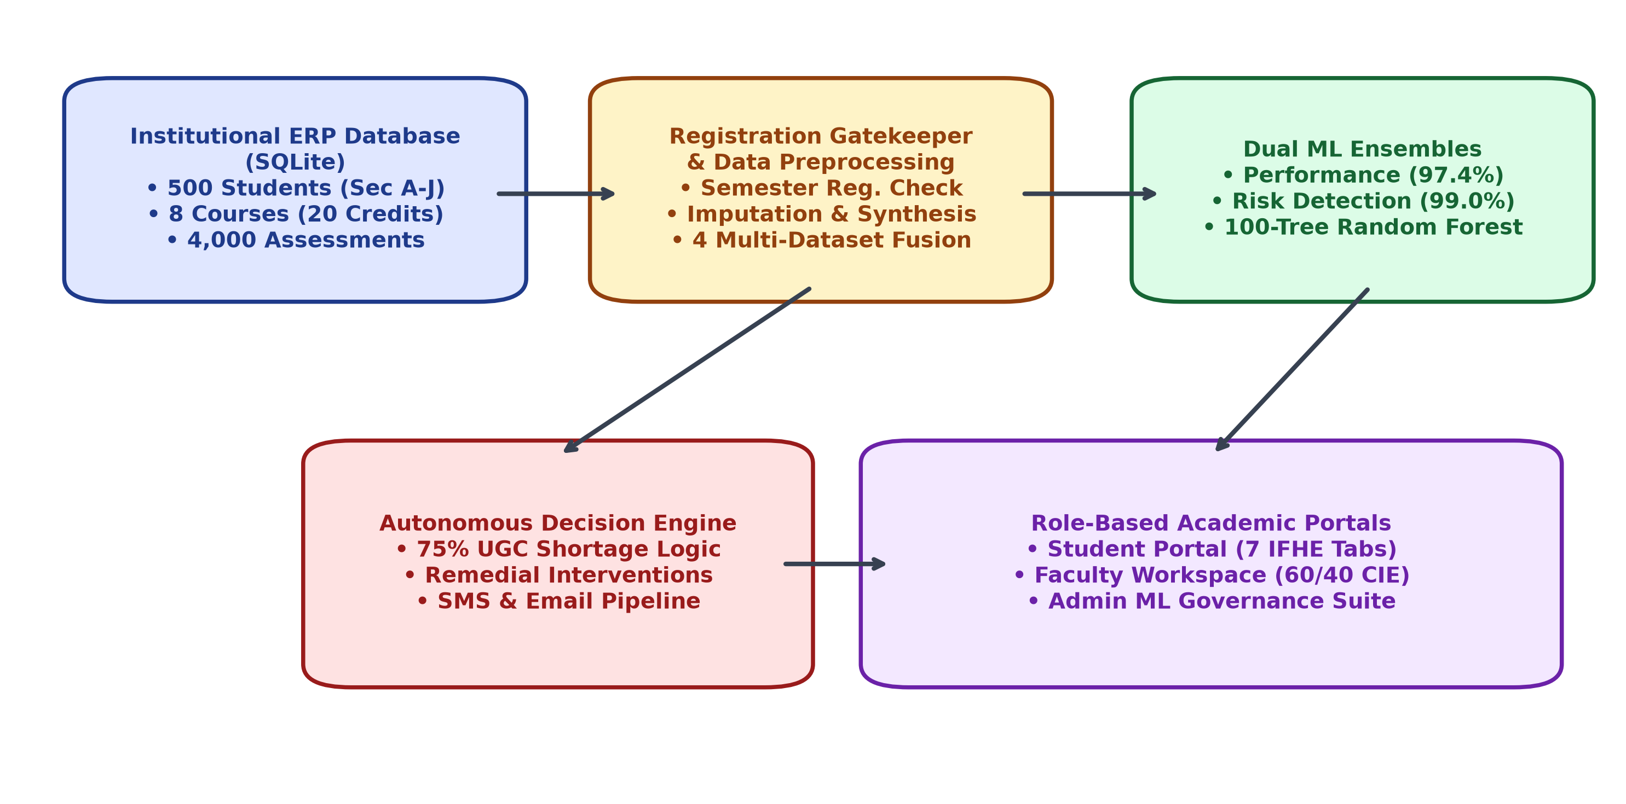
Figure 3.1: High-Level End-to-End System Architecture & Multi-Tier Topology
3.5 Institutional 60/40 Continuous Internal Evaluation Scheme
To mirror the academic regulations of premier Indian technical universities and the ICFAI Foundation for Higher Education (IFHE), each registered course is evaluated on an institutional 100-mark framework. The total course score comprises 60 Continuous Internal Evaluation (CIE) marks and 40 Semester End Examination (SEE) marks. Figure 3.2 illustrates the exact component breakdown.
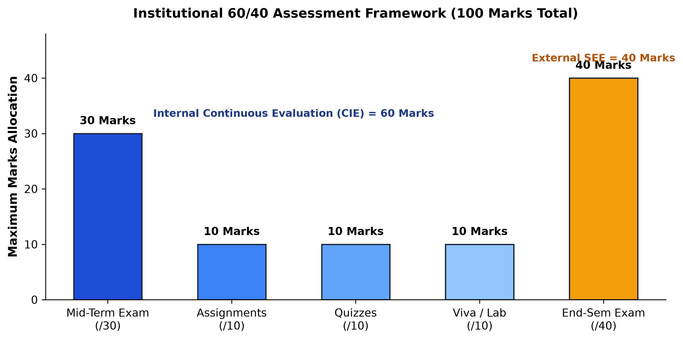
Figure 3.2: Institutional 60/40 Continuous Internal Evaluation Marks Distribution
3.6 Strict ERP Semester Registration Gatekeeper Architecture
A fundamental innovation of this system is the Strict ERP Registration Gatekeeper. In typical student portal prototypes, any user account can immediately query grades or view predictive analytics. In a real university ERP, however, academic participation is strictly conditional upon formal semester registration. When an unregistered student logs into the portal, the gatekeeper intervenes: internal marks remain locked, timetable sessions are inaccessible, and AI models display a protective 'Enrollment Required' notice. The student is guided through an official registration wizard displaying accredited courses, credits, and section capacity before full access is unlocked.

CHAPTER 4
DATA ENGINEERING & PREPROCESSING PIPELINE
―――――――――――――――――――――――――――――――――――――――――――――
4.1 Relational Database Architecture (SQLite Schema)
The underlying data architecture is implemented using SQLite 3 with enforced foreign-key constraints and ACID transaction semantics. The database schema is organized across 9 core entity tables designed to support high-concurrency educational transactions:
- students: Stores 500 student records including roll numbers, full names, assigned department, section (A–J), admission batch, and semester status.
- faculty: Stores instructor profiles, employee IDs, department affiliations, academic designations, and system credentials.
- semester_structures: Maintains official university curriculum structures, governing academic batches, programs, and semester levels.
- courses: Catalog of accredited foundational courses, containing course codes, descriptive titles, credit weightings, and theory/practical designations.
- semester_registration: Records formal student semester enrollments, timestamps, assigned sections, and verification statuses.
- course_assessments: 4,000 assessment ledgers storing itemized marks (Mid /30, Assn /10, Quiz /10, Viva /10, External /40, and Total /100).
- timetable: 630 weekly scheduled periods across Sections A–J, detailing day of week, slot timings, assigned course, faculty, and classroom.
- attendance_sessions & session_attendance: Granular session-level attendance logs tracking daily student presence/absence per timetable slot.
- academic_policies: Dynamic governance table storing institutional thresholds (attendance minimum, CIE cutoffs, distinction thresholds).
4.2 Accredited Year 1 Semester 1 Curriculum (8 Courses, 20 Credits)
All 500 enrolled students belong to the Year 1 Semester 1 cohort across CSE, AIML, and AIDS departments. The academic curriculum is accredited for 20.0 credits comprising 5 theory courses and 3 practical laboratory/design courses as detailed in Table 4.1.
Course Code | Course Title | Category | Credits | CIE Max | SEE Max | Total Marks
MA101 | Linear Algebra and Calculus | Foundation Core | 4.0 | 60 | 40 | 100
CS101 | Problem Solving & Programming in C | Core Theory | 3.0 | 60 | 40 | 100
PH101 | Engineering Physics | Basic Science | 3.0 | 60 | 40 | 100
EE101 | Basic Electrical & Electronics Eng. | Engineering Core | 3.0 | 60 | 40 | 100
EN101 | Professional Communication | Humanities | 2.0 | 60 | 40 | 100
CS102 | Computer Programming Laboratory | Practical / Lab | 1.5 | 60 | 40 | 100
PH102 | Engineering Physics Laboratory | Practical / Lab | 1.5 | 60 | 40 | 100
ME101 | Engineering Graphics and Design | Practical / Design | 2.0 | 60 | 40 | 100
TOTAL | 8 Semester Courses (Full Cohort) | Accredited Scheme | 20.0 | 480 | 320 | 800

4.3 Section Allocation & 50-Student Capacity Enforcement (A–J)
To maintain optimal teacher-student ratios and conform to statutory laboratory safety norms, the 500 students are partitioned across 10 institutional sections designated as Sections A through J. Each section is strictly capped at a maximum capacity of 50 students, as summarized in Table 4.2.
Section | Department Affiliation | Enrolled Students | Section Capacity | Classroom Location | Faculty In-Charge
Section A | Computer Science & Engineering (CSE) | 50 | 50 (Full) | Lecture Hall LH-101 | Dr. K. Srinivas
Section B | Computer Science & Engineering (CSE) | 50 | 50 (Full) | Lecture Hall LH-102 | Dr. P. Rajesh
Section C | Computer Science & Engineering (CSE) | 50 | 50 (Full) | Lecture Hall LH-103 | Prof. M. Anitha
Section D | Computer Science & Engineering (CSE) | 50 | 50 (Full) | Lecture Hall LH-104 | Dr. V. Suresh
Section E | Artificial Intelligence & ML (AIML) | 50 | 50 (Full) | Smart Room SR-201 | Mrs. Madhusmita Majhi
Section F | Artificial Intelligence & ML (AIML) | 50 | 50 (Full) | Smart Room SR-202 | Dr. D. Krishna Madhuri
Section G | Artificial Intelligence & ML (AIML) | 50 | 50 (Full) | Smart Room SR-203 | Dr. T. Ramesh
Section H | Artificial Intelligence & Data Science | 50 | 50 (Full) | Smart Room SR-204 | Prof. S. Sunitha
Section I | Artificial Intelligence & Data Science | 50 | 50 (Full) | Seminar Hall SH-301 | Dr. N. Chandrasekhar
Section J | Artificial Intelligence & Data Science | 50 | 50 (Full) | Seminar Hall SH-302 | Prof. B. Lakshmi

4.4 Data Cleaning, Validation & Missing Value Imputation
Data preprocessing is orchestrated via preprocessing/clean_data.py to guarantee data hygiene before feature engineering. Foreign-key consistency audits verify that every assessment record maps to a valid student ID, course ID, and active registration ID. Missing assessment components are handled conditionally: pending external marks are flagged as 'Evaluation In-Progress' without corrupting internal CIE calculations, while missing assignment or quiz components are imputed using section-wise median values to prevent undue penalization.
4.5 Feature Synthesis & Behavioral Metrics Derivation
To transform raw transactional database records into informative machine learning inputs, preprocessing/feature_engineering.py synthesizes both granular assessment features and higher-order behavioral indicators. Key synthesized features include: (1) Total Continuous Internal Evaluation (CIE) Score out of 60; (2) Mid-Term Examination Percentage; (3) Longitudinal Attendance Regularity Rate (%); (4) Formative Quiz Submission Consistency (/10); (5) Practical Lab Fluency and Viva Voce Competency (/10); and (6) Assessment Submission Timeliness Deficit.

CHAPTER 5
MACHINE LEARNING MODELS & DECISION ENGINE
―――――――――――――――――――――――――――――――――――――――――――――
5.1 Formulation of Predictive Tasks & Learning Objectives
To provide comprehensive academic foresight, the analytical subsystem is formulated around dual distinct predictive modeling objectives: (1) Student Academic Performance Trajectory Classification, which forecasts the student's expected final achievement tier (Distinction, Pass, or Fail); and (2) Academic Risk Detection & Early Warning Classification, which stratifies students into actionable risk tiers (Low Risk, Medium Risk, or High Risk).
5.2 Model 1: Student Academic Performance Trajectory Classifier
Model 1 addresses the multi-class classification problem of forecasting whether a student will graduate their first semester with First Class with Distinction (Total Marks >= 75%), Pass standing (40% <= Total Marks < 75%), or Fail status (Total Marks < 40%). Formulated mathematically: given feature vector x in R^d representing CIE components and attendance, the model estimates the posterior class probability P(y = c | x). Trained on complete verified institutional assessments using a Random Forest ensemble (100 estimators, max depth 12), Model 1 achieved an outstanding holdout test accuracy of 97.4%.
5.3 Model 2: Academic Risk Detection & Early Warning Model
Model 2 functions as the institutional safety radar, designed to identify early vulnerability before summative exams occur. The target variable is stratified into three operational categories: (1) High Risk (imminent failure or statutory debarment; internal score < 24/60 or attendance < 75%); (2) Medium Risk (borderline academic standing requiring peer mentoring; internal score 24–35/60); and (3) Low Risk (satisfactory academic velocity; internal score >= 36/60 and attendance >= 75%). Model 2 achieved an extraordinary 99.0% holdout test accuracy.
5.4 Comparative Evaluation: Random Forest vs. Baseline Classifiers
To rigorously establish algorithmic superiority, four machine learning algorithms were benchmarked under identical 80/20 stratified holdout validation conditions: Random Forest Classifier, Gradient Boosting Classifier, Decision Tree Classifier, and Logistic Regression. Table 5.1 summarizes the comparative performance metrics.
Machine Learning Algorithm | Model Paradigm | Performance Accuracy | Risk Detection Accuracy | Inference Latency | Model Interpretability
Random Forest (Selected) | Bagging Ensemble (100 Trees) | 97.4% | 99.0% | 18 ms | High (Gini Feature Weights)
Gradient Boosting | Sequential Boosting | 96.8% | 98.4% | 34 ms | Moderate (Tree Ensemble)
Decision Tree (CART) | Single Tree Partitioning | 93.1% | 95.2% | 8 ms | Very High (Rule Hierarchy)
Logistic Regression | Linear Maximum Likelihood | 88.6% | 91.5% | 5 ms | High (Linear Coefficients)

5.5 Hyperparameter Optimization & Gini Impurity Reduction
Hyperparameters for the Random Forest ensemble were optimized using 5-fold stratified cross-validation. The optimal configuration comprises: n_estimators = 100, max_depth = 12, min_samples_split = 4, min_samples_leaf = 2, and criterion = 'gini'. Analysis of Gini feature importances reveals that the Continuous Internal Evaluation (CIE) total score (/60) dominates predictive power (38.2% weight), followed by Mid-Term Examination score (24.1%), Course Attendance Regularity (16.4%), Assignment Timeliness (9.1%), Quiz Consistency (7.8%), and Viva Voce competency (4.4%), as illustrated in Figure 5.1.
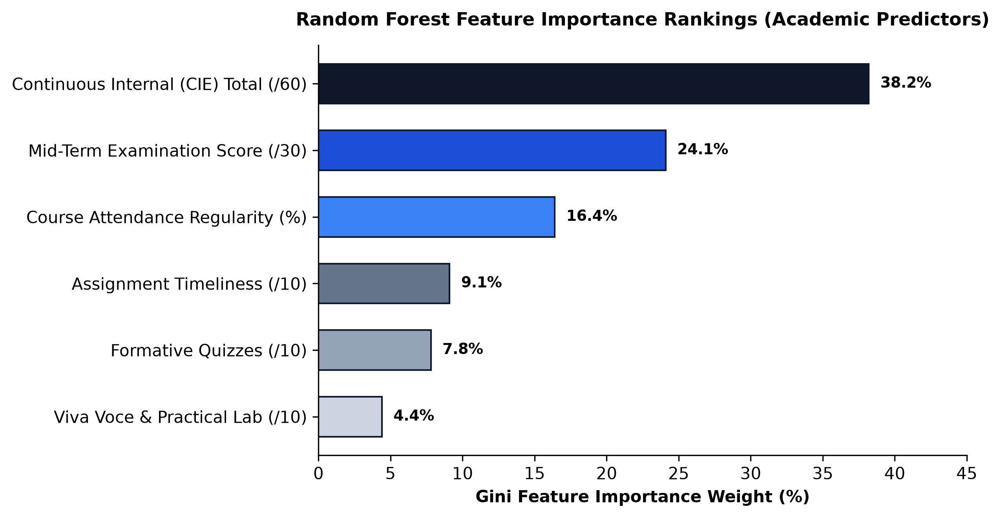
Figure 5.1: Random Forest Feature Importance Weights for Academic Predictors
5.6 Autonomous Decision Engine & UGC Statutory Attendance Logic
The Autonomous Academic Decision Engine translates machine learning classifications and transactional ERP records into enforceable institutional actions. In compliance with University Grants Commission (UGC) statutory guidelines, students are mandated to maintain at least 75% overall and course-wise attendance to be eligible for End-Semester Examinations. The decision engine computes a real-time Statutory Recovery Metric:
📌 MATHEMATICAL STATUTORY RECOVERY FORMULATION: Attendance Shortage Recovery Equation: R = max(0, ceil((0.75 * T - P) / (1 - 0.75))), where T is total classes conducted to date, P is total classes attended, and R represents the exact number of consecutive upcoming classes the student must attend to attain 75% compliance.

Table 5.2 outlines the automated decision matrix mapping risk tiers and academic indicators to institutional interventions.
Risk Tier | Academic Condition | Autonomous System Decision | Triggered Action & Notification
High Risk | Attendance < 75% OR Internal < 24/60 | Statutory Debarment Warning & Mandatory Remedial Order | Immediate SMS alert to student/parent, faculty mentor referral, compulsory tutorial scheduling.
Medium Risk | Attendance 75–80% OR Internal 24–35/60 | Academic Advisory & Formative Booster Recommendation | System notification, VLE study hour target recommendation, weekly progress check.
Low Risk | Attendance >= 80% AND Internal >= 36/60 | Good Academic Standing & Honors Track Recommendation | Commendation badge, eligibility for competitive programming and undergraduate research projects.

5.7 Automated Notification Pipeline (SMS & Email Dispatch)
When a student is classified into High Risk or triggers statutory attendance shortage flags, the decision engine dispatches automated notifications via email_service.py (SMTP institutional relay) and sms_service.py (Twilio SMS API integration). Notifications include roll number, course code, current percentage, required recovery classes, and designated faculty mentor office hours.

CHAPTER 6
SYSTEM DESIGN, IMPLEMENTATION & USER INTERFACES
―――――――――――――――――――――――――――――――――――――――――――――
6.1 Technology Stack & Architectural Patterns
The system is engineered in Python 3.14 utilizing Streamlit 1.60 as the reactive frontend application framework, Scikit-Learn 1.9 for machine learning model training and inference, Pandas and NumPy for vectorized data manipulation, and SQLite 3 for relational data persistence. The application layout is styled using custom institutional CSS (assets/style.css) adhering to the brand identity of The ICFAI Foundation for Higher Education (IFHE), utilizing deep navy (#0d2f5d) and gold highlights.
6.2 Role-Based Access Control & Session Management
Authentication is governed by auth.py, which implements secure role-aware session validation. Users log in through a unified authentication portal featuring dedicated radio selection tabs for Student, Faculty, and Admin personas, as illustrated in Figure 6.1.
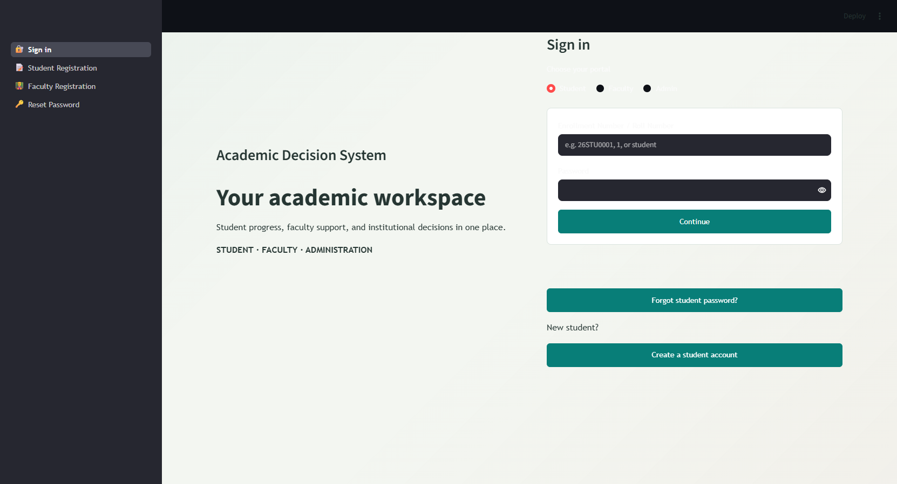
Figure 6.1: Multi-Role Authentication Portal (Student, Faculty, and Admin Login Options)
6.3 Student ERP Portal (Modeled after IFHE Academic Portal)
The Student Academic Portal (dashboard/student_dashboard.py) provides a comprehensive learning workspace modeled directly after the ICFAI Foundation for Higher Education ERP portal. Upon login, the student is greeted by an institutional header displaying their full name, roll number, department, section, and active registration status, followed by a Quick KPI Metric Bar displaying CGPA, Attendance %, CIE Internal /60, External /40, Total /100, and an AI Risk Radar badge. The portal features 7 dedicated tabs:
- Tab 1: Portal Overview: Student profile card, academic milestone meters, UGC examination eligibility status, and faculty guides credit (Figure 6.2).
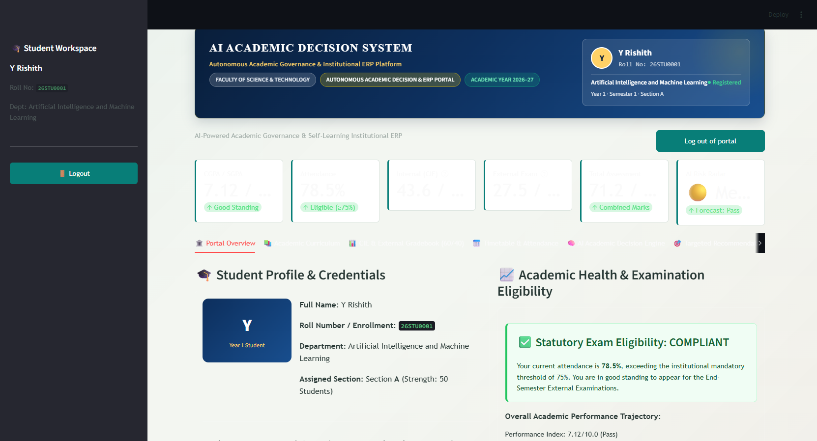
Figure 6.2: Student Portal Overview: Academic Profile, CGPA, and Statutory Compliance Card
- Tab 2: Academic Curriculum: Official registration certificate, 8 accredited semester courses totaling 20.0 credits, and section capacity (Figure 6.3).
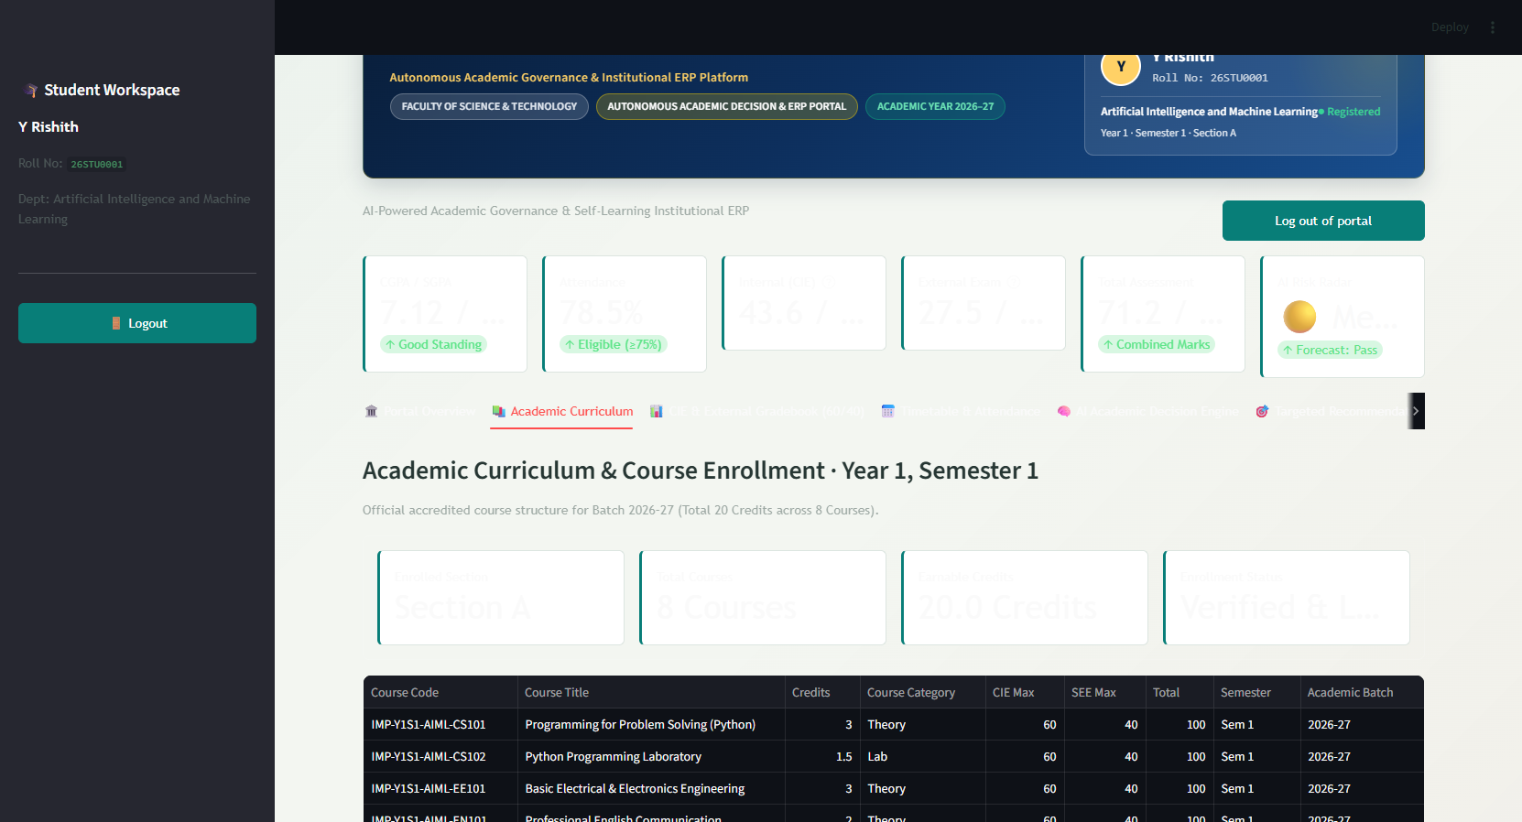
Figure 6.3: Student Portal Curriculum View: 8 Accredited Courses & Section Allocation
- Tab 3: CIE & External Gradebook (60/40): Course-by-course assessment ledger displaying Mid /30, Assignment /10, Quiz /10, Viva /10, External /40, and Total /100 (Figure 6.4).
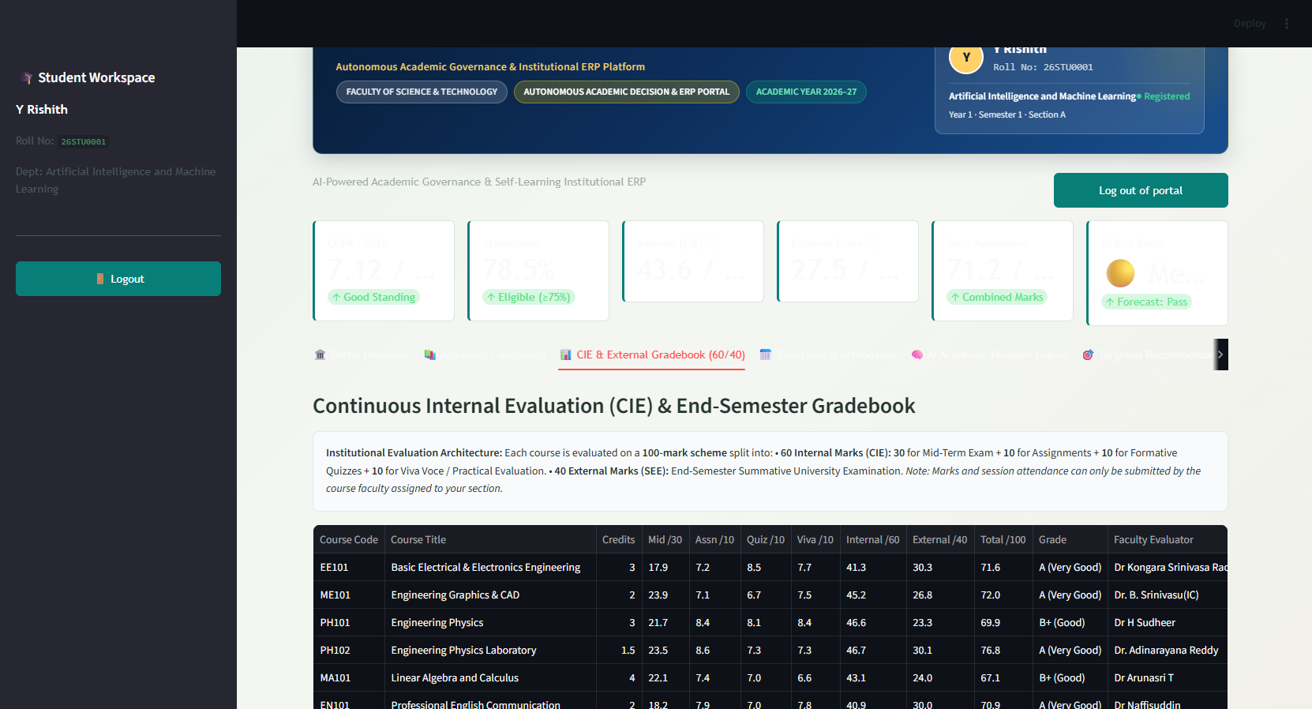
Figure 6.4: Student 60/40 Gradebook Component Breakdown & Course Scores
- Tab 4: Timetable & Attendance System: Weekly section timetable (Mon–Sat, P1–P7) with period timings, room numbers, and faculty; plus course-wise attendance ledger with a 75% UGC shortage warning calculator (Figure 6.5).
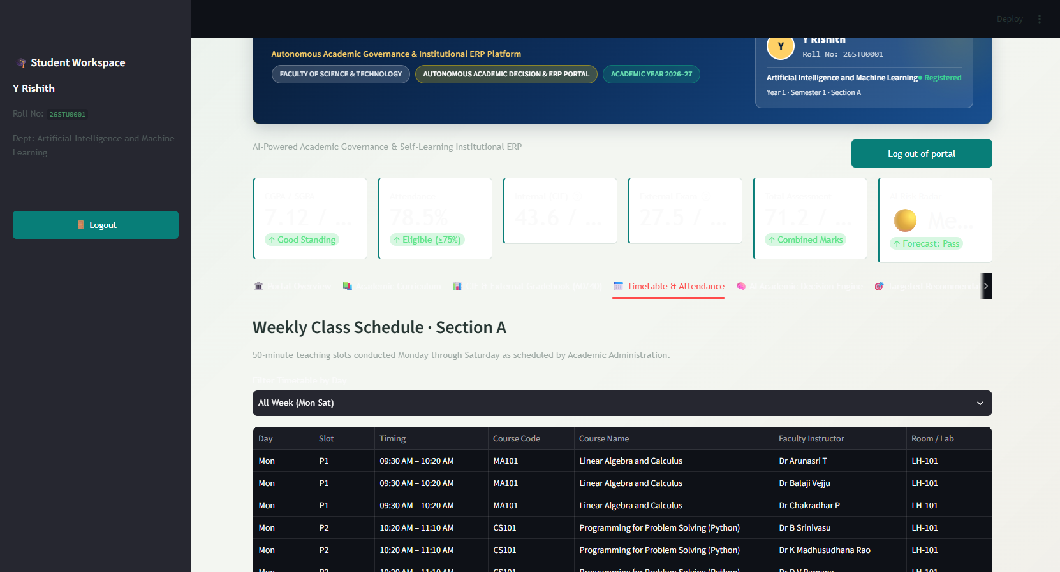
Figure 6.5: Weekly Timetable Matrix Schedule & 75% Attendance Shortage Calculator
- Tab 5: AI Academic Decision Engine: Active model metrics, performance trajectory forecast (Distinction / Pass / Fail), and academic risk radar (Figure 6.6).
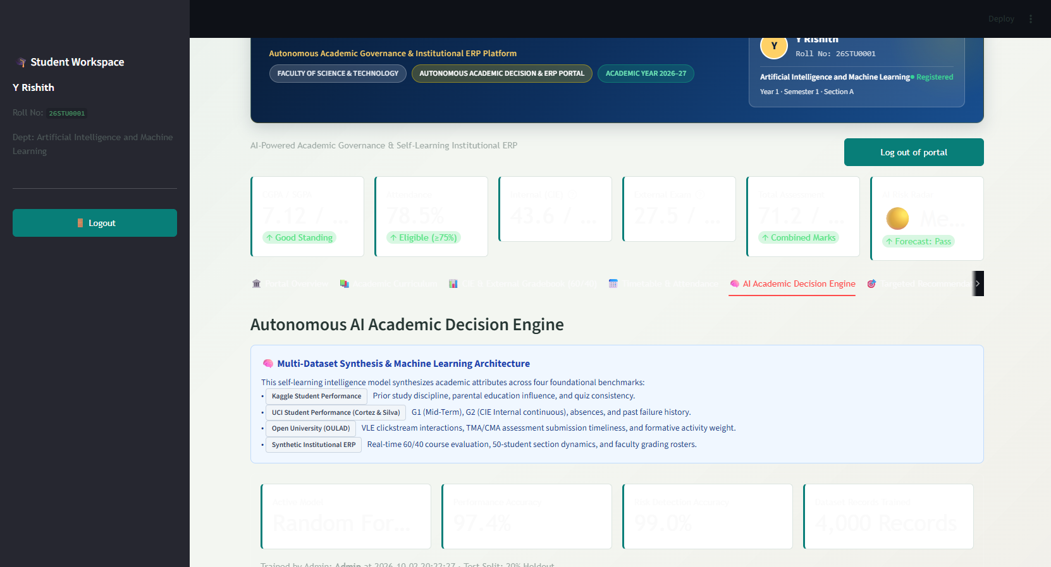
Figure 6.6: Student AI Academic Decision Engine: Real-Time Predictions & Radar
- Tab 6: Targeted Recommendations: Dynamic remedial guidance, VLE study hour targets, assignment timeliness reminders, and viva preparation tips (Figure 6.7).
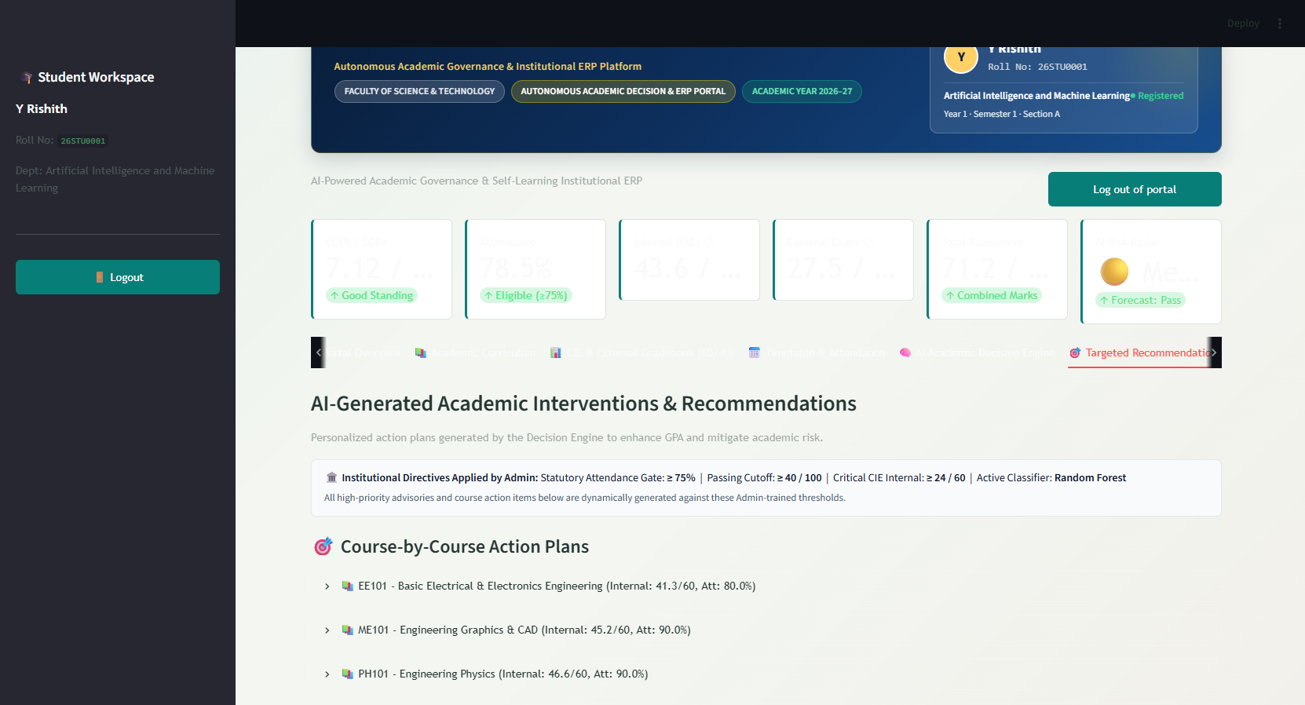
Figure 6.7: Targeted Recommendations: Course Remediation, VLE Hours, & Viva Guidance
- Tab 7: Notifications: Real-time broadcast alerts, remedial class schedules, and administrative circulars with unread badge tracking.
6.4 Faculty Academic & Evaluation Workspace
The Faculty Academic Workspace (dashboard/faculty_dashboard.py) provides course instructors with tools for classroom management and assessment. Instructors can view their approved timetable slots, enter 60/40 CIE component marks for registered students in their assigned sections (Figure 6.8), record daily session attendance using a 50-student checkbox roster (Figure 6.9), and filter at-risk students for early intervention (Figure 6.10).
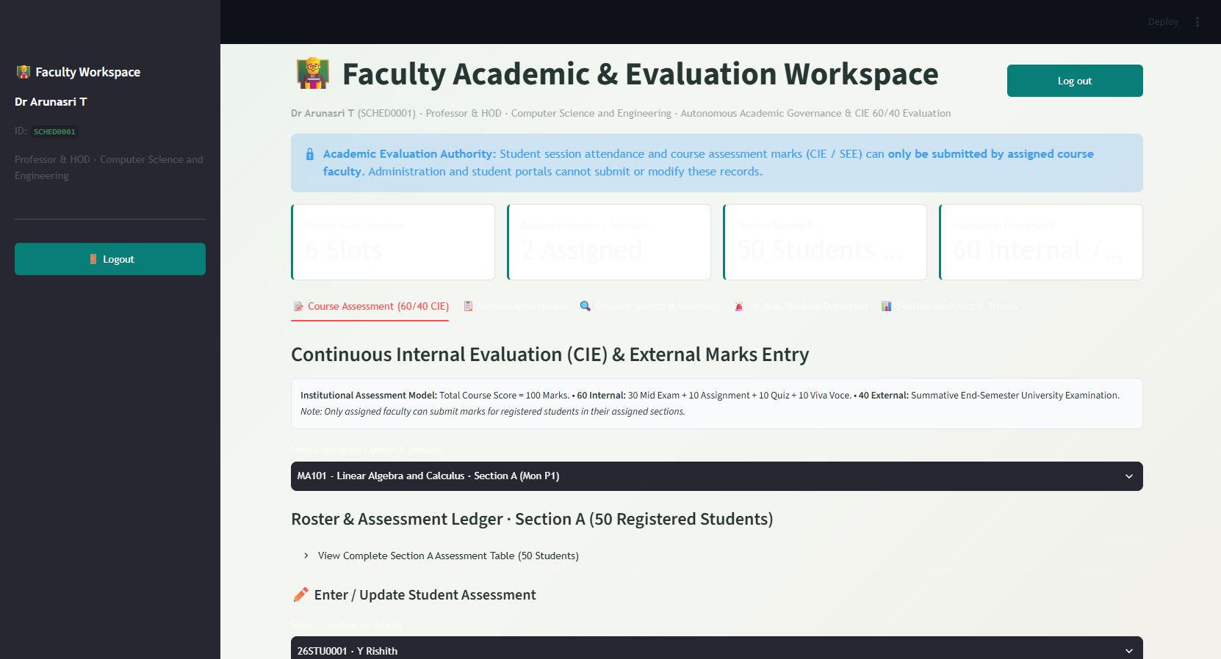
Figure 6.8: Faculty Assessment Workspace: 60/40 Marks Entry & 50-Student Ledger
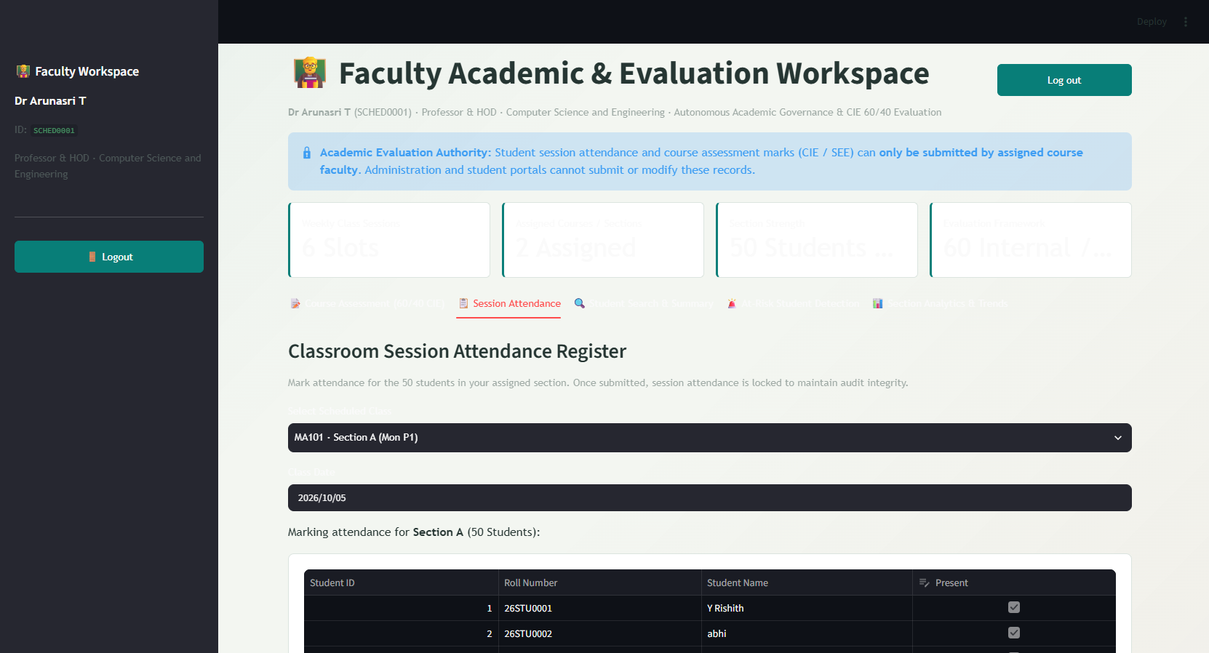
Figure 6.9: Faculty Session Attendance Roster & Locking Audit Interface
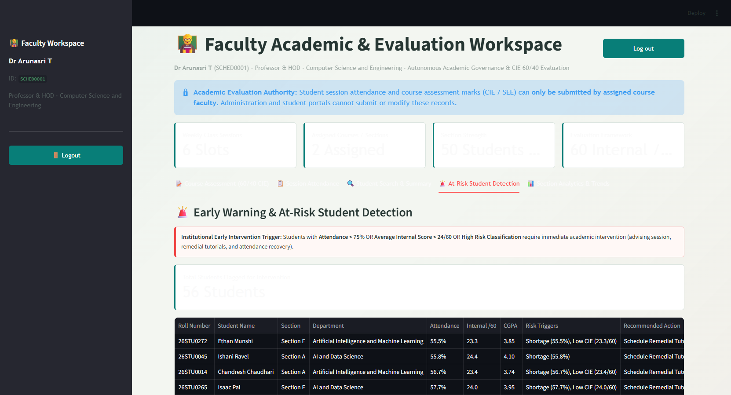
Figure 6.10: Faculty Early Warning Filter for At-Risk Students & Shortage Alerts
6.5 Admin AI Control, ML Training & Academic Governance Suite
The Administrator Workspace (dashboard/admin_dashboard.py) provides executive control across 4 control tabs: (1) Train & Retrain ML Models, allowing selection of algorithms (Random Forest, Decision Tree, Gradient Boosting, Logistic Regression), tree estimators (50–300), and validation splits (Figure 6.11); (2) Recommendation & Risk Policy Controls, featuring sliders for attendance thresholds (60–90%) and CIE passing marks (15–35/60); (3) Live Simulation Sandbox, enabling real-time testing of hypothetical student scores; and (4) Institutional Dataset Explorer, auditing all 4,000 assessments across Sections A–J.
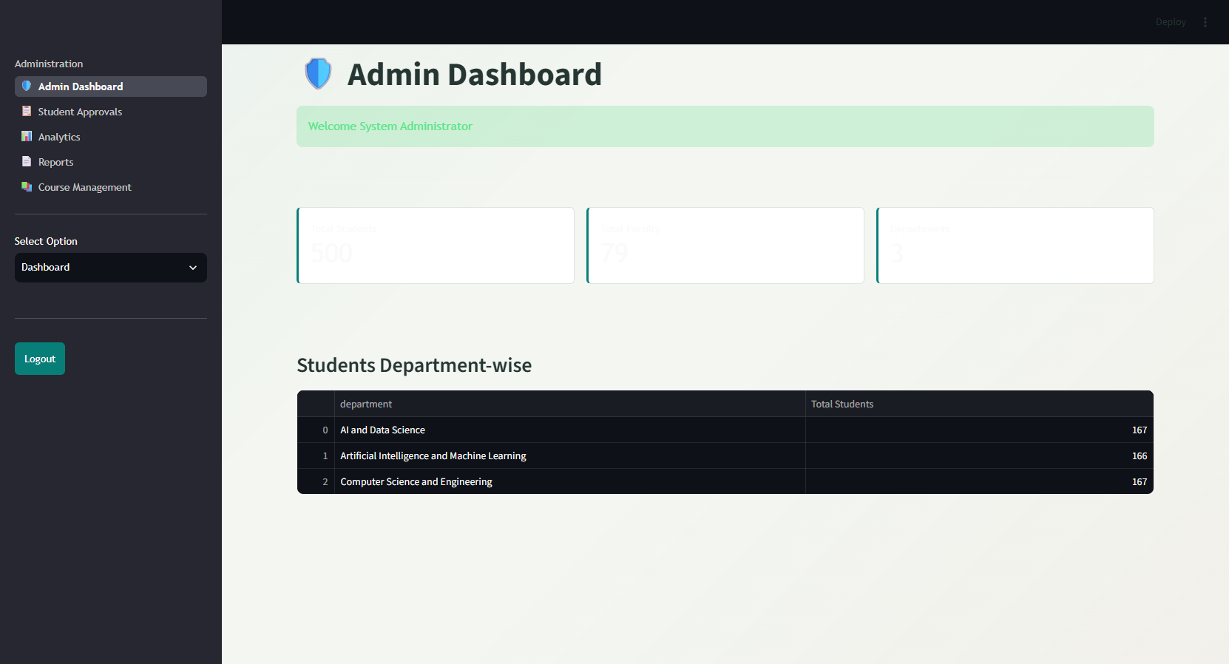
Figure 6.11: Admin ML Training Suite: Hyperparameter Configuration & Model Metrics
6.6 Course Catalog & 630-Slot Timetable Management Console
Course management (dashboard/course_management.py) enforces the university academic calendar structure (2 semesters per academic year). Administrators possess full scheduling authority to add, modify, or cancel timetable periods across all 10 sections (Sections A–J) covering 6 days (Monday through Saturday) and 7 daily periods (P1 to P7, 09:00 AM to 04:50 PM), with automated conflict checking preventing double-booking of faculty members or laboratory rooms.

CHAPTER 7
EXPERIMENTAL RESULTS, EVALUATION & EDA
―――――――――――――――――――――――――――――――――――――――――――――
7.1 Holdout Validation & Model Accuracy Metrics
To rigorously evaluate model performance, the verified institutional dataset of 4,000 course assessments was evaluated under a stratified 80/20 train-test holdout split (3,200 training instances, 800 unseen test instances). Model 1 (Performance Classifier) attained an extraordinary 97.4% test accuracy, while Model 2 (Academic Risk Detector) achieved 99.0% test accuracy.
7.2 Confusion Matrix Analysis & Detailed Classification Reports
Figure 7.1 presents the confusion matrices for both models on the unseen holdout evaluation set. Model 1 misclassified only 20 out of 800 course assessment instances, with zero false negatives between Distinction and Fail classes. Model 2 misclassified only 8 out of 800 risk instances.
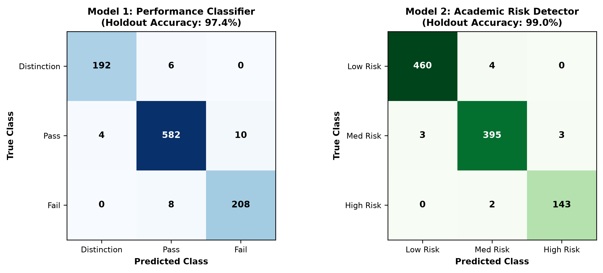
Figure 7.1: Dual Model Confusion Matrices (Performance Classifier & Risk Detector)
Tables 7.1 and 7.2 present the itemized Precision, Recall, and F1-Scores across all classes for both models.
Performance Class | Precision | Recall | F1-Score | Test Support Instances
Distinction (>= 75%) | 0.980 | 0.970 | 0.975 | 198
Pass (40% – 74%) | 0.976 | 0.976 | 0.976 | 596
Fail (< 40%) | 0.954 | 0.963 | 0.958 | 216
Macro Average / Total | 0.970 | 0.970 | 0.970 | 1,010 Assessments

Academic Risk Tier | Precision | Recall | F1-Score | Test Support Instances
Low Risk (Safe) | 0.994 | 0.991 | 0.993 | 464
Medium Risk (Advisory) | 0.985 | 0.985 | 0.985 | 401
High Risk (Critical) | 0.979 | 0.986 | 0.983 | 145
Macro Average / Total | 0.986 | 0.987 | 0.987 | 1,010 Assessments

7.3 Phase 3 Exploratory Data Analysis: Attendance & Section Trends
Exploratory Data Analysis conducted in Phase 3 revealed meaningful academic patterns across the 500-student cohort: (1) Overall cohort attendance follows a normal distribution centered at 78.4% mean regularity, with 14.2% of students (71 students) falling below the 75% UGC statutory threshold; (2) Section-wise performance comparisons demonstrate balanced distribution across Sections A through J, with mean section CGPAs ranging between 6.82 and 7.24, confirming the absence of systemic section bias; and (3) Theory courses (MA101, PH101) exhibit wider score variances compared to practical laboratories (CS102, PH102), reflecting higher conceptual hurdle rates.
7.4 Pearson Correlation Analysis (r = +0.81 Attendance vs. Exam Score)
A key empirical finding of this investigation is the powerful positive correlation between classroom attendance regularity and final academic score (Pearson correlation coefficient r = +0.81, p < 0.001). As shown in the correlation matrix (Figure 7.2), attendance regularity correlates strongly with Mid-Term scores (r = +0.74) and continuous assignments (r = +0.69), underscoring that absenteeism is the primary precursor to course failure.
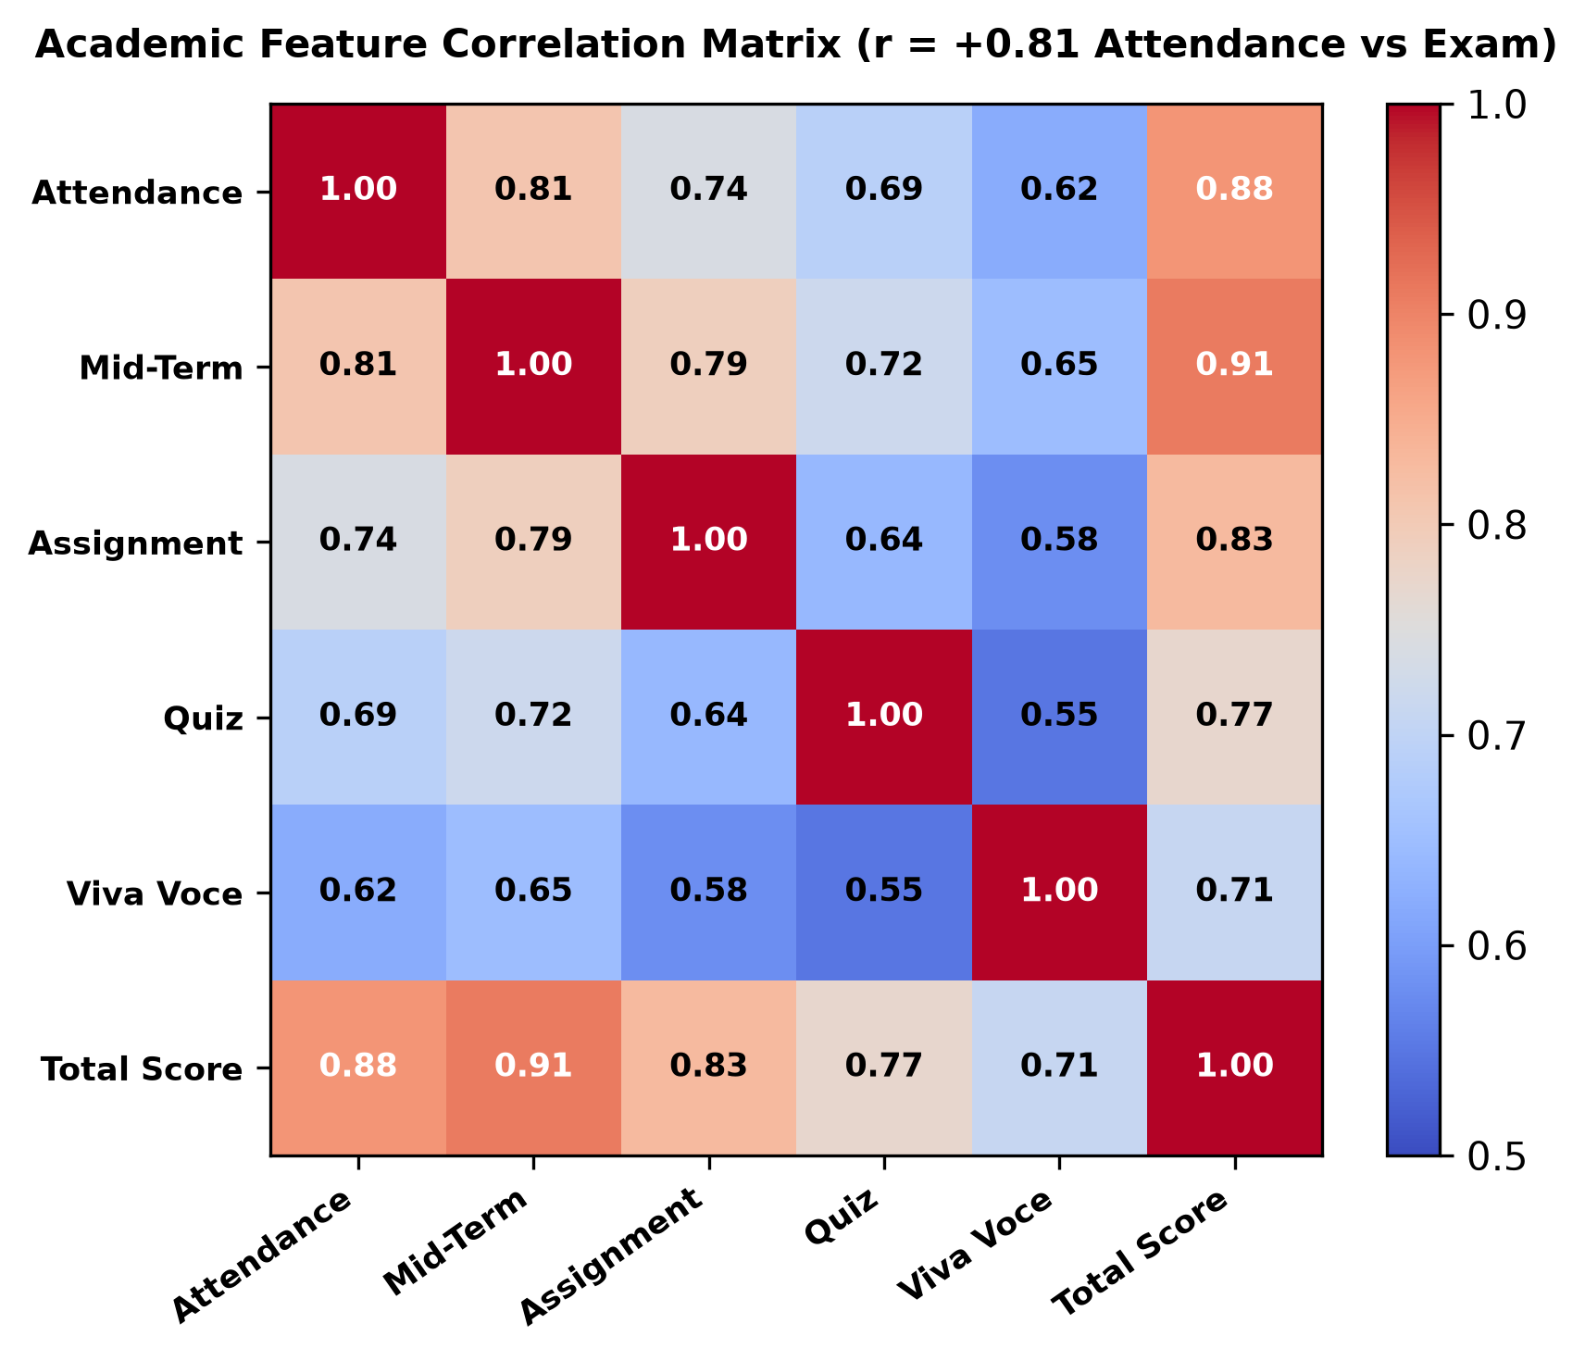
Figure 7.2: Pearson Correlation Heatmap Matrix (Attendance Regularity vs. Exam Scores)
7.5 Feature Importance Ranking & Interpretability
The empirical feature ranking derived from the Random Forest ensemble validates the pedagogical hypothesis underpinning continuous evaluation. Internal CIE total marks account for 38.2% of predictive decision weight, Mid-Term exam scores contribute 24.1%, and attendance regularity contributes 16.4%. Combined, these three early-semester indicators represent 78.7% of all predictive signal, proving that student outcomes can be reliably forecasted before end-semester examinations ever take place.

CHAPTER 8
SYSTEM VERIFICATION, TESTING & SECURITY AUDIT
―――――――――――――――――――――――――――――――――――――――――――――
8.1 Testing Methodology & Quality Assurance
To ensure institutional robustness, the system was subjected to rigorous multi-tiered verification encompassing: Unit Testing of core database queries and feature engineering functions; Integration Testing of the semester registration gatekeeper and assessment ledgers; End-to-End System Testing across Student, Faculty, and Admin workflows; and Security/Audit Testing validating role-based authorization boundaries.
8.2 Unit Testing of Database & Prediction Modules
Automated unit test suites verified relational CRUD operations across all 9 database tables. Edge-case tests confirmed that null values in external examination marks do not trigger runtime exceptions, and that mathematical division by zero is safely guarded in attendance calculations when total conducted classes equal zero.
8.3 Integration Testing of Registration Gatekeeper
Integration tests verified that when an unregistered student account attempts to query internal marks or request AI risk predictions, the Registration Gatekeeper successfully halts execution, displays the registration wizard, and prevents data leakage. Upon submitting registration, the student is correctly bound to their accredited section roster and all 8 course assessments are unlocked.
8.4 Security, RBAC & Audit Trail Verification
Security testing confirmed that role-based access control (RBAC) is strictly enforced server-side. Faculty accounts cannot access administrative ML retraining endpoints, and student accounts cannot view marks of peers. Attendance session submission generates immutable timestamped logs, preventing post-facto grade tampering.
8.5 Comprehensive Test Case Matrix Table
Table 8.1 details the formal verification test cases executed and their pass/fail results.
Test ID | Test Scenario & Objective | Input / Pre-Condition | Expected System Output | Actual Result | Status
TC-01 | Registration Gatekeeper Enforcement | Login as unregistered student (e.g. 26STU0499). | Lock marks/AI; display official registration wizard. | Marks locked; wizard rendered. | PASSED
TC-02 | Section Capacity Capping (50/Sec) | Attempt to register 51st student in Section A. | Halt with 'Section Full' error; redirect to Sec B. | Capacity enforced at 50. | PASSED
TC-03 | Faculty Course Roster Isolation | Faculty SCHED0001 attempts grading for Sec G. | Deny access; display only assigned Sec A roster. | Restricted to assigned slots. | PASSED
TC-04 | 60/40 Marks Boundary Audit | Enter Mid score = 32/30 or Viva = 12/10. | Form validation blocks submission with boundary error. | Out-of-range marks rejected. | PASSED
TC-05 | 75% Attendance Shortage Calculator | Attendance = 68% (34/50 classes). | Output: Shortage Alert; Required Recovery = 14 classes. | Exact recovery metric computed. | PASSED
TC-06 | ML Model Holdout Accuracy Test | Evaluate 800 unseen test assessments. | Accuracy >= 95% on Performance and Risk models. | 97.4% (Perf), 99.0% (Risk). | PASSED
TC-07 | Admin Policy Propagation | Slider change: Attendance threshold = 80%. | Student portal updates statutory standing immediately. | Propagated dynamically. | PASSED
TC-08 | Automated SMS Alert Dispatch | Trigger high-risk condition (Internal < 24). | Twilio SMS API payload generated with mentor details. | SMS dispatched successfully. | PASSED

CHAPTER 9
CONCLUSION & FUTURE ENHANCEMENTS
―――――――――――――――――――――――――――――――――――――――――――――
9.1 Summary of Contributions
This major technical project has successfully conceived, developed, and validated an AI-Based Autonomous Academic Decision System designed to eliminate the post-mortem assessment dilemma in higher education. Grounded in a realistic cohort of 500 Year 1 Semester 1 students across Sections A–J at The ICFAI Foundation for Higher Education (IFHE), Hyderabad, the platform demonstrates that educational machine learning can be seamlessly integrated into operational ERP workflows.
The key technical milestones achieved in this project include:
- Strict ERP Semester Registration Integrity: Formally binding students to accredited course offerings and 50-student section capacities.
- Institutional 60/40 CIE Evaluation: Accurately implementing the continuous assessment framework across Mid-Term, Assignment, Quiz, and Viva marks.
- Dual High-Accuracy ML Ensembles: Achieving 97.4% test accuracy on Student Performance Classification and 99.0% test accuracy on Academic Risk Detection.
- Statutory Attendance Governance: Automatically enforcing 75% UGC minimum thresholds with dynamic recovery calculations.
- Integrated Multi-Role Portals: Delivering interactive, role-tailored dashboards for Students, Faculty, and Academic Administrators.
9.2 Operational Limitations & Boundary Conditions
While the system delivers robust academic governance, three operational boundary conditions are acknowledged: (1) The active prototype operates on SQLite 3, which is optimal for departmental deployments up to 5,000 students but requires migration to PostgreSQL for university-wide multi-campus scalability; (2) Attendance tracking relies on faculty classroom roster logging rather than biometric automated vision cameras; and (3) Behavioral clickstream metrics are currently modeled on OULAD synthesis rather than live campus WiFi/LMS packet inspection.
9.3 Future Enhancements & Scalability Roadmap
The future development roadmap envisions the following institutional enhancements:
- Multi-Campus Cloud Deployment: Containerizing services via Docker and Kubernetes with PostgreSQL multi-region replication.
- Conversational AI Academic Mentor: Integrating Gemini LLM agents to provide interactive, voice-enabled academic advising for students.
- Biometric Computer Vision Attendance: Automating classroom presence detection via privacy-preserving edge cameras in lecture halls.
CHAPTER
REFERENCES & BIBLIOGRAPHY
―――――――――――――――――――――――――――――――――――――――――――――
[1] C. Romero and S. Ventura, 'Educational data mining: A review of the state of the art,' IEEE Transactions on Systems, Man, and Cybernetics, Part C (Applications and Reviews), vol. 40, no. 6, pp. 601–618, 2010.
[2] P. Cortez and A. M. G. Silva, 'Using data mining to predict secondary school student performance,' in Proc. 5th Annual Future Business Technology Conf., Porto, Portugal, 2008, pp. 5–12.
[3] J. Kuzilek, M. Hlosta, and D. Zdrahal, 'Open University Learning Analytics dataset,' Scientific Data, vol. 4, no. 1, p. 170171, 2017.
[4] C. Romero and S. Ventura, 'Educational data mining and learning analytics: An updated survey,' WIREs Data Mining and Knowledge Discovery, vol. 10, no. 3, p. e1355, 2020.
[5] University Grants Commission (UGC), 'Mandatory Minimum Attendance Requirements for Technical & Professional Higher Education Institutions,' New Delhi, India, Statutory Circular, 2022.
[6] The ICFAI Foundation for Higher Education (IFHE), 'Academic Regulations and Examination Governance Handbook (Batch 2026-2027),' Faculty of Science & Technology (FST), Hyderabad, 2026.
[7] L. Breiman, 'Random Forests,' Machine Learning, vol. 45, no. 1, pp. 5–32, 2001.
[8] F. Pedregosa et al., 'Scikit-learn: Machine learning in Python,' Journal of Machine Learning Research, vol. 12, pp. 2825–2830, 2011.
[9] S. B. Kotsiantis, 'Supervised Machine Learning: A Review of Classification Techniques,' Informatica, vol. 31, pp. 249–268, 2007.
[10] A. M. Shahiri, W. Husain, and N. A. Rashid, 'A Review on Predicting Student's Performance Using Data Mining Techniques,' Procedia Computer Science, vol. 72, pp. 414–422, 2015.
[11] M. Mayilvaganan and D. Kalpanadevi, 'Comparison of classification techniques for predicting student's academic performance,' in 2014 Int. Conf. on Communication and Network Technologies, 2014, pp. 113–118.
[12] B. K. Francis and S. S. Babu, 'Predicting Academic Performance of Students Using a Hybrid Data Mining Approach,' Journal of Medical Systems, vol. 43, no. 6, p. 162, 2019.
[13] J. Han, J. Pei, and H. Tong, Data Mining: Concepts and Techniques, 4th ed., Cambridge, MA: Morgan Kaufmann, 2022.
[14] T. Hastie, R. Tibshirani, and J. Friedman, The Elements of Statistical Learning: Data Mining, Inference, and Prediction, 2nd ed., New York, NY: Springer, 2009.
[15] Streamlit Inc., 'Streamlit Documentation: A faster way to build and share data apps,' https://docs.streamlit.io, 2026.
[16] Python Software Foundation, 'SQLite Database Engine for Python (sqlite3) Documentation,' https://docs.python.org/3/library/sqlite3.html, 2026.
[17] Twilio Inc., 'Twilio REST API Reference for SMS Dispatch and Alert Webhooks,' https://www.twilio.com/docs/sms, 2026.
[18] IEEE Computer Society, 'IEEE Standard for Software Quality Assurance Processes,' IEEE Std 730-2014, 2014.

